What are network devices?

Network devices are a wide variety of devices that help keep the internet world in order. Ranging from routers to switches these unique devices help serves its own purpose in making sure millions of users are connected every day and hour. In this paper im going to go over some of the more important devices that are essential to the I.T world and what particular purpose they serves.

First is the repeater operates at the physical layer. Its job is to regenerate the signal over the same network before the signal becomes too weak or corrupted so as to extend the length to which the signal can be transmitted over the same network. An important point to be noted about repeaters is that they do not amplify the signal. When the signal becomes weak, they copy the signal bit by bit and regenerate it at the original strength. Without them when signal becomes weak and the computer or device cant function as quickly.

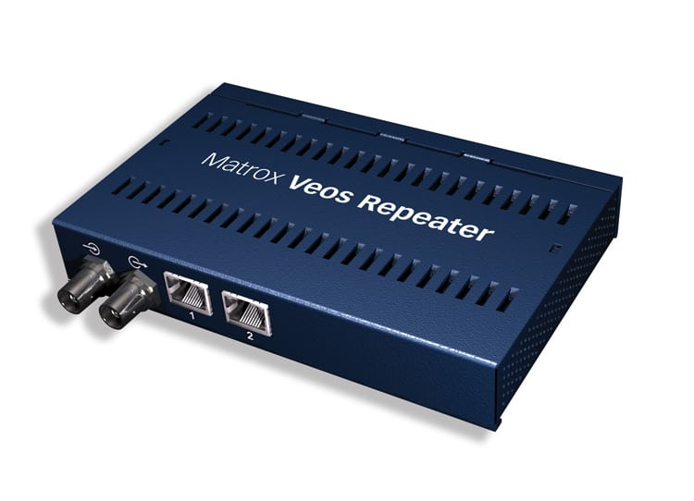

Next device maybe the most important for civilians in this day and age A router. This device is like a switch that routes data packets based on their IP addresses. Router is mainly a Network Layer device. Routers normally connect LANs and WANs together and have a dynamically updating routing table based on which they make decisions on routing the data packets. Router divide broadcast domains of hosts connected through it. I say that these are the most important because people needs these to have wifi in their homes and businesses and router are the most stable source for establishing good connection while at home.

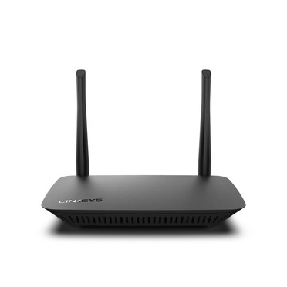

Lastly the device that I feel is also important is the switch A switch is a multiport bridge with a buffer and a design that can boost its efficiency and performance. A switch is a data link layer device. The switch can perform error checking before forwarding data, that makes it very efficient as it does not forward packets that have errors and forward good packets selectively to correct port only.

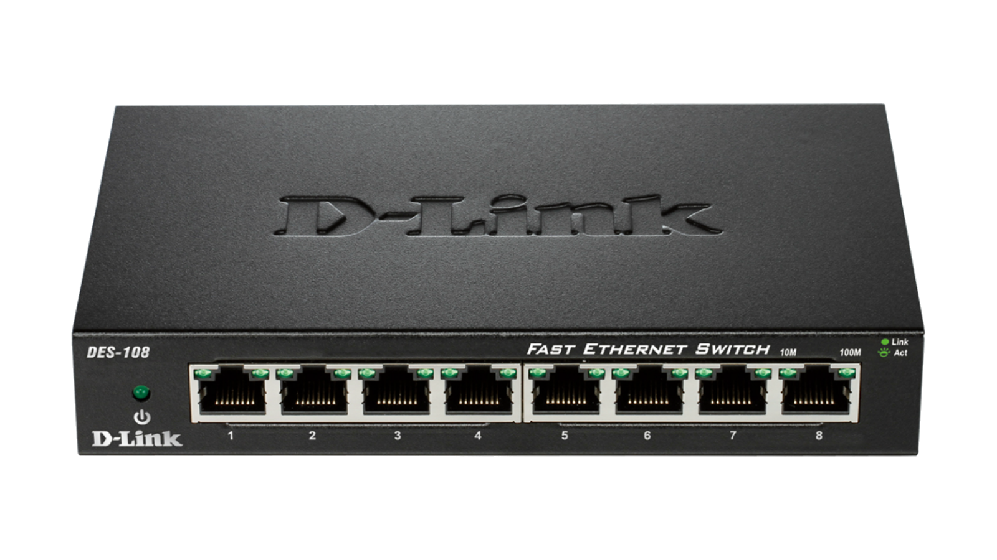

To conclude these are some devices that to me, are important to not only to the internet world and I.T. guys but to the everyday world civilians as well. With how the world set up today more than likey people may have to deal with no if one but all of the devices and many more!